**What is transcranial magnetic stimulation (TMS)?**

Transcranial magnetic stimulation (TMS) is a non-invasive treatment that involves using a magnetic coil to influence your brain’s natural electrical activity. This treatment sees widespread use for a variety of mental health and brain-related conditions.

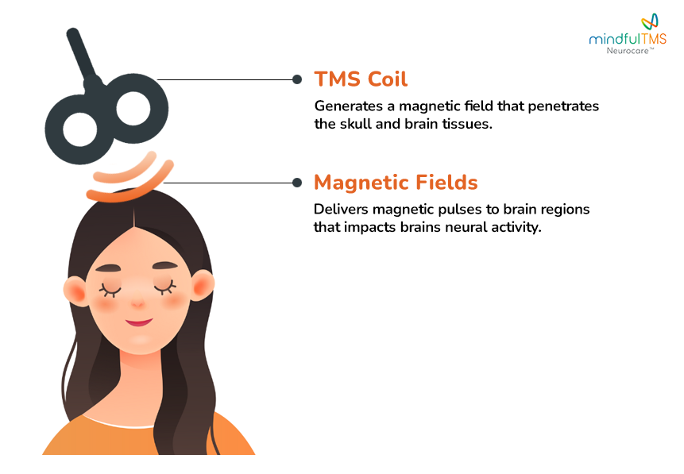

**Is TMS for me?**

TMS is often a treatment that can help when other treatment options are unsuccessful.

It’s also an important option if you're considering a non-invasive option that does not involve medication.

TMS can also offer an alternative to treatments that are riskier like electroconvulsive therapy (ECT).

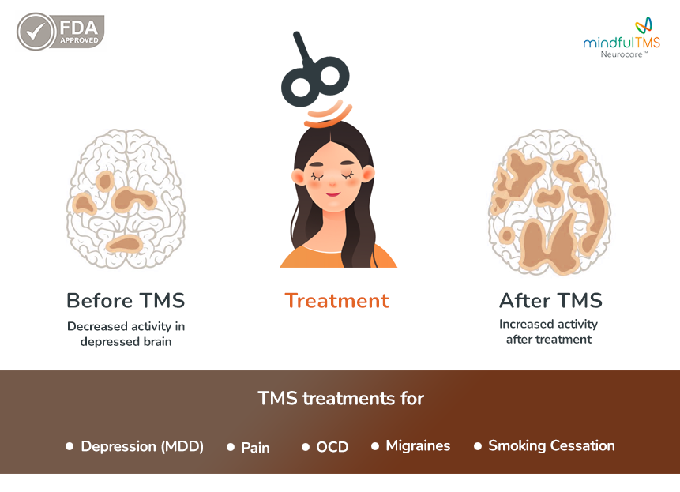

**How TMS Works**

During a TMS treatment session:

1. **Setup:** A healthcare professional places the TMS coil on your head, targeting the specific brain area based on your condition.
2. **Sending Pulses:** The coil sends magnetic pulses into your brain.
3. **Brain Stimulation:** These pulses stimulate the neurons in the targeted area, helping to balance brain activity and improve your symptoms.
4. **Session Duration:** Each session takes about 20-37 minutes, and you typically have treatments 5 days a week for 5-6 weeks.

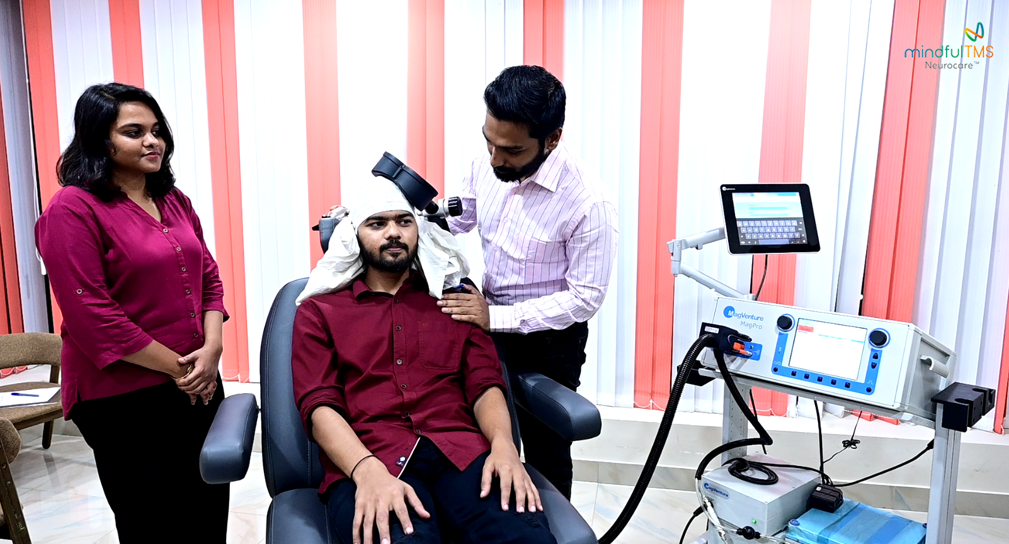

**What Does the TMS Coil Do?**

**The TMS coil**:

1. **Creates Magnetic Fields:**
   * The coil makes strong magnetic fields that are directed to specific parts of your brain that need treatment.
2. **Targets Specific Brain Areas:**
   * 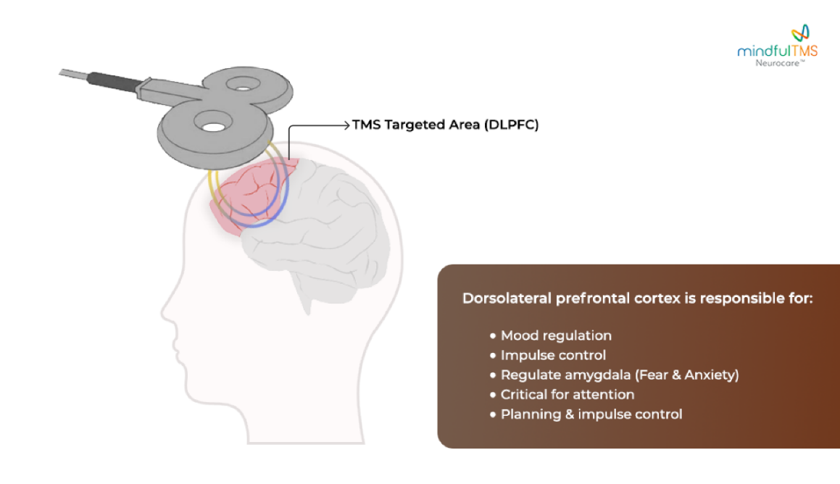The shape of the coil helps focus the magnetic fields on exact areas of your brain related to your condition (like depression, OCD, or anxiety). This precise targeting ensures the treatment is effective.
3. **Non-Invasive Application:**
   * The coil is placed against your scalp near the area being treated.
   * The treatment is done from outside your head.

**What Do the Magnetic Pulses Do?**

**Magnetic pulses** are what make TMS effective. Here’s how they work:

1. **Stimulate Brain Cells:**
   * The magnetic pulses help activate or regulate the brain cells (neurons) in those regions where the coil is targeted.

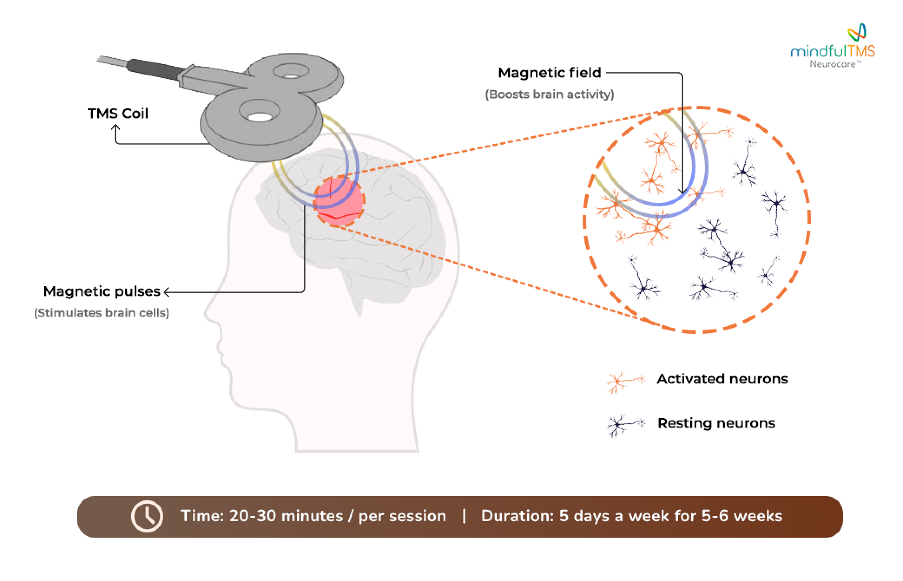

1. **Boost Brain Activity:**
   * For conditions like **Major Depressive Disorder (MDD)**, some brain areas may be less active. The pulses help **increase** activity in these areas, improving your mood.
   * For **Obsessive-Compulsive Disorder (OCD)** and **Generalized Anxiety Disorder (GAD)**, a different protocol (or recipe) is used where the pulses can calm down overactive brain areas, reducing anxiety and unwanted thoughts.

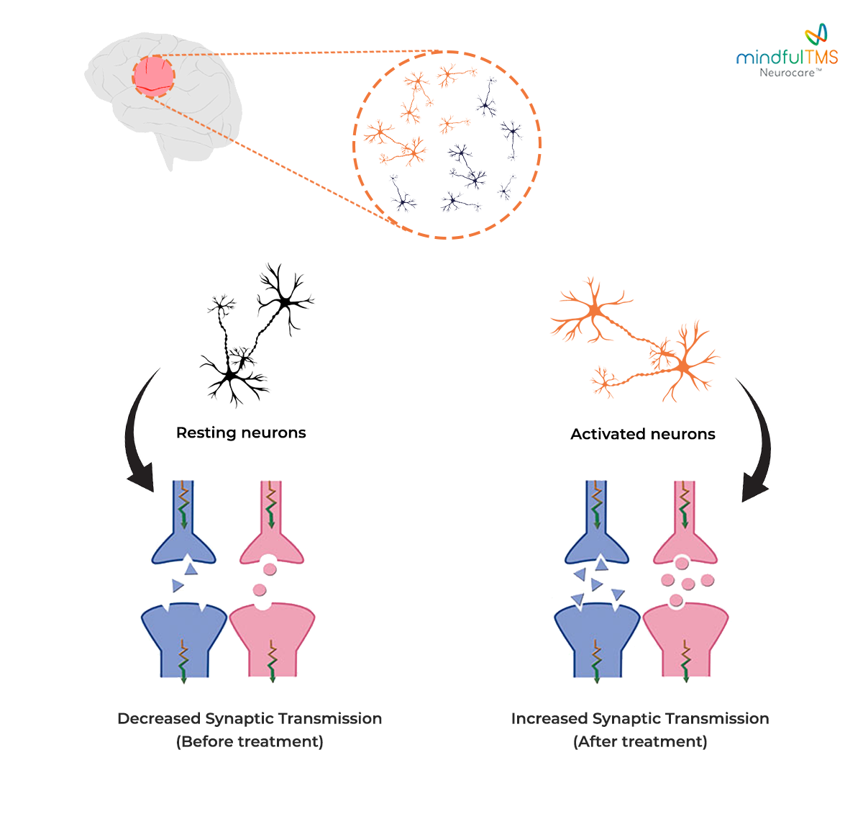

1. **Promote Brain Flexibility:**
   * Your brain can change and adapt, a feature called neuroplasticity, **but takes time.**
   * By giving 25-30 sessions over 5-6 weeks, the magnetic pulses encourage your brain to form **new, healthier connections and maintain them**, which can help reduce symptoms of your condition.